# CHAPTER ONE

# INTRODUCTION

## 1.1 PROJECT BACKGROUND

E-learning refers to the use of electronic media and information and communication technologies (ICT) in education to facilitate and enhance learning and teaching. It broadly includes all form of educational technology to create experiences that educate our fellow human beings which is synonymous with multimedia learning, technology-enhanced learning, computer-based instruction etc.

When it comes to education, the model has been pretty straight forward - up until the early 2000s, education was in a classroom of students with a teacher who led the process. Physical presence was a requisite, and any other type of learning was questionable at best. Then the internet happened and education was redefined.

Now that affordable solutions exist for both computers and internet, it only takes a good E-learning tool for education to be facilitated from virtually anywhere. Technology has advanced so much that the geographical gap is bridged with the use of tools that make one feels as though one is inside classroom. E-learning offers the ability to share material in all kinds of formats such as videos, slideshows, word documents and PDFs. Conducting webinars (live online classes) and communicating with professors via chat and message forums is also an option available to users.

With the right tool, various processes can be automated such as a course with set materials and automatically marked tests. E-learning is an affordable (and often free) solution which provides the learners with the ability to fit learning around their lifestyles, effectively allowing even the busiest person to further a career and gain new qualifications.

Some of the most important developments in education have happened since the launch of the internet. These days’ learners are well versed in the use of smartphones, text messaging and using the internet to participate in and running an online course. Message boards, social media and various other means of online communication allow learners to keep in touch and discuss course related matters, while providing for a sense of community.

In the fast-paced world of E-learning the available technologies to make a course new and exciting are always changing, and course content can and should be updated quickly to give students the very latest information. This is especially important if the E-learning training is being given to students or employees in a sector where being up-to-date on educational and industrial developments is of the utmost importance.

Overall, traditional learning is expensive, takes a long time and the results can vary. E-learning offers an alternative that is faster, cheaper and potentially better.

## 1.2 AIM AND OBJECTIVES

## **1.2.1 Aim**

In order to deal with the issues of illiteracy in our society; the project aims to use the internet as a medium of teaching and learning which could be accessible via laptops, tablets and smartphones.

### 1.2.2 Objectives

The objectives of this project are:

1. To automate academic learning process using web application.
2. To use the concept of E-learning to ensure education is available to people that do not have access to physical educational facilities.

## 1.3 SIGNIFICANCE OF THE STUDY

E-learning has a lot of benefits that makes the creation and delivery processes easier and hassle-free either for teachers looking to engage students in a more interactive way or for students that are eager to have up-to-date knowledge about their chosen field of study.

Traditional learning method often takes a relatively longer time to master a course or profession while E-learning saves time. In the case of face-to-face learning, the location limits attendance to a group of learners who have the ability to participate in the area, and in the case of time, it limits the crowd to those who can attend at a specific time. E-learning, on the other hand, facilitates learning without having to organize when and where everyone who is interested in a course can be present.

A student at some points in time needs to pay exorbitant amounts of money to acquire updated versions of textbooks for school or college. While textbooks often become obsolete after a certain period of time, the need to constantly acquire new editions is not present in E-learning. The added benefit comes in with the ability to replay the lecture and gain even more out of it. Students that missed out can read the materials and view the recordings, or students that attended can watch it again to further their understanding.

## 1.4 SCOPE OF THE PROJECT WORK

The scope of this project is to create a Lecturer-Student web platform that facilitates remote teaching on the part of the lecturer and remote learning on the part of the student. This will be achieved by developing a web application from where lecturers and students can carry out their respective roles when they log in to the portal. The lecture will be able to add course materials in terms of videos/audios, slideshows, word documents and PDFs while the students can view them and download by logging to their portal. The lecturer shall be able to upload questions with deadlines which students will be required to answer before the time lapse. There will also be a community where questions could be asked and answers replied.

# CHAPTER TWO

# LITERATURE REVIEW

## 2.1 INTRODUCTION

A number of researches have reported that whilst the delivery of online courses enhance student learning in some respects, they also caution against the technology without adequate regard for the learning outcome being sought (Buckley, 2003; Lawther and Walker, 2001; Willet, 2002). There remain a number of researchers who warn that the teaching should drive the technology and not vice versa (Petrides, 2002). Smith and Ferguson (2002) argued that much can be gained from online delivery; the encouragement of deeper levels of discussion, the ability to consider responses due to the asynchronous nature of the medium, and the minimization (if not elimination) of the power differential between student and teacher. Because courses given entirely or in part online have such obvious advantages with respect to student access and potential cost savings, their development and use has exploded over the last several years.

Although little is now known about online learning for example, how the students respond subjectively to it and what strategies have proven desirable from their point of view (Hiltz et al. 2000; Kearsley, 2000; Sener, 2001; Wenger et al. 1999; Clark, 1993; Reeves, 1997; Song, Singleton, Hill, and Koh, 2004), little is still known about how online courses deliver compares to conventional course delivery with respect to objective measures of student learning. Some have reported no significant differences in learning outcomes between delivery modes (Barry and Runyane 1995; Carey 2001; Caywood and Duckett 2003; Cheng, Lehman and Armstrong, 1991; Hiltz, 1993; Russell, Sankaran and Bui 2000), some have shown that online students fared worse (Brown and Liedholm, 2001; Wang and Newlin 2000), some have found that online students fare better (Derouza and Fleming, 2003; Maki, Maki, Patterson and Whittaker, 2000; Maki and Maki, 2002), but few have compared entire courses and still fewer have managed to overcome the many methodical obstacle to rigorous contrasts (Phipps et al.1999; Carey, 2001; IHEP 1999).

However Smith and Ferguson (2002) also warned that with these benefits come a number of disadvantages including the potential technology failures, the lack of conventional face to face teaching and therefore interpersonal cues, and from the instructors viewpoint ,a great deal of time and effort in converting text based content to information suitable for online delivery. Overall it is suggested that even though online delivery offers new challenges, it is viewed as worthwhile by those on both sides i.e. the learners and the facilitators (Smith and Ferguson, 2002).

## 2.2 ELECTRONIC LEARNING (E LEARNING)

E-learning is a general term used to refer to form of learning in which the instruction and student are separated are separated by space or time where the gap between the two is bridged by the use of online technologies. E-learning is used interchangeably in a wide variety of contexts. In companies it is referred to the strategies that use the company network to deliver training courses to employees. In distance education Universities it is defined as a planned teaching/learning experiences that uses a wide spectrum of technologies mainly internet to reach learners at a distance. Lately in most universities, e-learning is used to define a specific mode to attend a course or programs of study where the student rarely, if ever, attend face-to-face or for on campus access to education facilities, because they study online (Guenaneche and Radigales, 2008).

## 2.2.1 Advantages and Disadvantages of E-Learning

There are a number of advantages to offering courses completely online, these may includes

1. Access to courses/programs outside of students’ geographical region with possibility of decreased educational cost, as well as allowing the student to cater to their environmental learning preferences.
2. Online education also allows students to personalize their education so that it is tailored to their unique learning style.
3. Many students appreciate the conveniences of online courses (Coombs-Richardson, 2007; Leisure, Davis & Thievon, 2000; Sampson, 2003; Yazon, Mayer-Smith & Redfield, 2002). While assignments, quizzes and discussions in online classes are still expected to be completed by their assigned due date, students are usually not require to log on at set times and are able to complete learning activities at a time that is convenient for them (Parise, 2000; Roblyer, 1999; Yazon; Mayer-Smith & Redfield, 2002). This allows students with children the opportunity to work around their children’s schedules, and reduces time students spend commuting to campus (Roblyer, 1999).
4. Online courses provide global interaction. Students from all over the world are able to log on to the same courses and share ideas and experiences.
5. It is either to hold students accountable in online courses as all of their transactions are traceable (praise,2000; tang and byrne,2007), some online learning management system allows instructors to monitor which course component students have used and how long they have spent using each component. For example, instructors have the ability to create windows in which a student must complete a task in a given amount of time, monitor who is currently online and record the time and date assignments are received.

However, the disadvantages of courses online include:

1. Online courses may not be appropriate for all students. Students in online courses are expected to engage in self-directed and autonomous learning while taking greater responsibility for the mastery of course content.
2. Also students in online courses need higher level of motivation and self discipline than students in lecture classes to be successful as argued by Coombs-Richardson (2007), Parise (2000) and Sampson (2003).
3. Computer literacy - students have different degrees of familiarity with the computer, internet and software programs. This can adversely affect their ability to participate to the fullest.
4. Limitation of technology - there are some things a computer simply cannot do such as real-life simulations, chemical laboratory experiment, and medical dissections. Visualizations are useful, but not as good as actually being there.

## 2.3 INSTRUCTIONAL TECHNOLOGY AND DESIGN

Maki and Maki (2003) pointed out that in comparisons that favor online delivery, “the design of the course (the instruction technology), and not the computerized delivery, produced the differences favouring the web-based courses”. They also pointed out, however, that online courses can more readily enforce deadlines, therefore encouraging more engagement with the course materials, they can offer students more immediate feedback, and they can make learning more active, all features of the educational experience that we know improve learning outcomes.

According to Scheines et al. (2001), experiments performed in 2000 and 2001 compared a conventional face-to-face lecture format to an online format, measuring learning outcomes and a variety of student’s behaviour that might explain differences in learning outcomes. Differences were removed in the designs of the online and face-to-face lecture versions of the course except those that were essential to the delivery modes, for example the immediate feedback and comprehension checks that are only available in online learning. In support of Maki and Maki (2003), Scheines et al. (2001) found out that the immediate feedback and active learning clearly helped, but also found out that online students were less likely to attend recitation sections. Overall, even controlling for pre-test and recitation attendance, it was established that students in the online version of the course did slightly better than students in the conventional face-to-face lecture version of the course independent of their lecturer, teaching assistant, gender, or any other feature measured.

In actual fact, it was therefore established that online interactive courses result in better performance in student examinations than the conventional face-to-face teaching system. So far, the question remains; will it be effective to replace the conventional teaching methods (especially in courses with large contents) with online courseware without affecting objectively what students learn from the course?

In further attestation to the claim stated earlier, works carried out by Ozad and Barkan (2004) revealed that a number of students learning in the same place, at the same rate, and the same linear manner tend to perform individually different from each other as established by developments in cognitive psychology. This has proven that each person is different and has a different map of learning. Furthermore, one of the key problems in education reform is that conventional teaching fails because students have no use or interest in much of the materials presented, yet in order expands their understanding of a given course, they must become involved in the entire teaching process.

## 2.4 ELEMENTS OF INSTRUCTIONAL DESIGN

In conventional teaching methods, lecturers disseminate information at a slower rate, but with the development in IT, the rate at sharing the new information and expectation of the students from education has increased enormously. Thus, instructional design has become more complex. Due to this; there is a need for raising teacher’s awareness to instructional design. Understanding and mastering instructional design will enable teacher to produce better learning materials. Instructional design here is then defines as:

“A process that comprises production and consumption. It involves all the political, strategic, technical and tactical activities used in solving pre-defined problems; planning, structuring, of the product and process of production” (Barkan and Ozad, 2002).

Instructional design thus addresses the following issues:

1. Reasons for production?
2. What to produce?
3. How to produce?
4. Materials for production?

Instructional media designs are of five types: text, graphics, images, audio, and video. Text involves letters, numbers, punctuation, special characters etc. Graphics include lines, circles, boxes, shading and colours. Images are pictures like photographs or paintings. Audio is the sound aspect of media like music and voice. Video is the successive picture presented sufficiently and rapidly to give the appearance of smooth motion. All these elements are essential to the development of the web channel where students can receive online lectures and courseware. The web channel can be made available with the aid of the following;

1. Computer Hardware/ Operation system
2. The internet/WWW
3. Design Tools and Applications
4. Channel Hosting and Registration
5. Courseware Materials

## 2.4.1 Computer and Operating System

To participate in online learning, students must have access to internet-enabled computers, which meet a minimum processor specification. Although this may be stating the obvious, it must still be mentioned as a relevant factor in online education. We cannot assume that every students has a home computer however; research has suggested that many university students may already have the computer and internet access necessary (Sinclair, 1999). Listed below are the hardware/software configurations of the computer systems needed by the developer or host and users

**Server machine:** is a machine that houses the database engine, web server and the application program. Server stores information and stores request from clients. This information includes all kinds of data; it also sends information to the client browser on how to display all this information. The server specification is as follows;

1. **CPU:** Intel Core 2 Duo
2. **Processor:** Processor speed up to 2GHZ
3. **Ram Size:** 3GB RAM
4. **Hard Disk:** 250GB HDD
5. **Operating System Software:** Windows XP/Vista Windows 7/8

**Server software pack:** WAMP server 2.0 (A pack for Window OS integrated with Apache HTTP server 2.2.8, MySQL server 5.0.51b, and PHP server interpretation 5.2.6). However, this is not required on the clients/students machine.

**Client/student machine:** the machine only provide interface for users to use the application through which users enter the required information as specified by the system before output can be displayed. This machine does not need much computer resources. The specification is as follows:

1. **CPU:** Intel Pentium 4 equivalent or higher.
2. **Processor:** processor speed (1GHZ)
3. **RAM Size:** 512MB RAM
4. **Hard Disk:** 60GB HDD
5. **Operating System Software:** Windows XP / Vista / 7 / 8
6. **Browser Application:** Internet Explorer 8 / Mozilla Firefox 27.0 / Google Chrome 32

The choice of the listed configuration is based on the available technology in this part of the world. Windows operating systems are readily available among the target population and will server as the platform for the e-learning design.

## 2.4.2. The Internet / WWW

The internet, a global network of computers was developed almost four decades ago with funding supplied by the United States’ Department of Defence. Originally designed to connect about a dozen universities and research organization using the computer, the internet today is accessible by hundreds of millions of computers worldwide. With the introduction of the World Wide Web (WWW) which allows computer users to locate and view multimedia-based documents on almost any subject over the internet, the internet has exploded into one of the world's premier communication mechanism.

The internet and the World Wide Web are surely amongst mankind's most important and profound inventions. The internet by and large has created a web of enthusiasm and creativity, which is commonly employed to the development of newer kind of sophistication. It provides a unique avenue where online and real-time processing of information can be combined with newly developed device to generate desired results.

## 2.4.3 Design Tools and Applications

Several application software have been employed in designing web pages but only few applications can allow web page editing with view options of design (WYSIWYG = drag and drop shorted for what you see is what you get) and codes. Some developers depend on writing the scripts or codes of their web pages using Notepad which does not support WYSIWYG viewing but have to preview it first in a browser before they have a feel of how their website looks. Adobe Dreamweaver is one of the few applications that allows a developer design web pages and at the same time preview the pages on the fly.

## 2.4.4 Channel Hosting and Registration

The channel hosting and registration are the processes involved in securing a domain name for the e-learning platform. A suitable name for the website will be determined by the institution developing the application. This application will be developed with standard measures and procedures and thus will be made ready for any user to deploy.

The process of domain name registration involves application for domain name registration from a reliable and trustworthy host on the internet. Yahoo, GoDaddy, Bluehost, Web4Africa etc. are examples of companies offering different plans for domain hosting.

With registration secured, domain name (defined by user) is registered if available and domain control panel (CPanel) password (also defined by user) is supplied to the user along with domain package. On the CPanel’s administrator page, there are many website management tools which will assist the webmaster in effectively managing the website and the application deployed on the website. Some of these tools include mailing and mail management tools, upload and download tools, website editing tools, folder management tools, database management tools, site submission and other development tools useful for effectual management. The lecture delivery application is then deployed by uploading files to the website public _html or httpdocs folder for online access.

## 2.4.5 Courseware Materials

Course materials needed for the project design include lecture notes, materials, textbooks, worked examples, past questions and solutions, and other necessary materials required for the purpose of online lecture delivery. These materials will be sourced for among lecturers, examination offices for past questions, libraries for textbooks, research works etc.

Lecture notes will be prepared in a standardized way so as to make necessary advantages of access and understanding available to the end users. These notes will also be prepared for download and printing purposes to enhance student's learning activities and abilities.

Other courseware materials will be standardized for the same purpose and will also be made available for assessment and comparison. Useful textbooks and research work will be prepared and necessary links will lead to materials not within reach of the developers.

## 2.5 REVIEW OF RELATED WORKS

A wide range of lecture delivery websites have been developed since the advent of internet technology in the early 90s. However, majority of these websites and their developers are faced with different kinds of challenges and limitations. While the bulk of their challenges have been resolved as newer technologies in information and communication evolved, newer challenges have faced these developers. Some of these lecture delivery websites are analyzed below.

## 2.5.1 HyWeb - Hybrid Web Teaching System

HyWeb, shorted for hybrid web teaching system (HDS) initially designed for use within a first-year multimedia course, offered at Griffith University, Gold Coast, Australia (Cranitch et al, 2000). The program of study is delivered using combination of online and traditional methods hence the name hybrid web. This involves using the internet with a variety of other media, which is supplied on CD. When deployed, Vicki Jones and Greg Cranitch argued that the amount of traditional teaching becomes reduced and students realized an increase in flexibility. The introduction of the removable media (CD) was an improvement on the efficiency of the website as internet speed and bandwidth became the first major challenge of the website (Cranitch et.al, 2000).

## 2.5.1.1 Technology Adopted in HyWeb

Two major technologies incorporated in HyWeb are the CD-ROM and Web technologies

The Web Technology – lecture is delivered via internet in variety of ways; slideshows, videos, sound, animation and downloadable document files. The internet lectures or "web-Lectures" will also include voice-over and demo movies in QuickTime and Real Video streaming synchronized with the lecture slides (Cranitch et.al, 2000).

CD-ROM - The CD is designed for use in conjunction with the website. On the student's first visit to the web site the HyWeb system will search for the CD. This is a vital component of the HyWeb system. CDs can accommodate high volume files such as graphics, audio/video files, animation and movie files required for teaching, which otherwise slow down the transfer rates. The content of the CD files would, in all probability be "constant" for the duration of the course, and therefore making it unlikely to be retrieved and synchronized with the material from the main server when students access the web page. However, HyWeb allows the system to retrieve files from the server if necessary.

### 2.5.1.2 Merits of HyWeb

1. The systems allows for last minute changes by the lecturer.

2. The lecturer can control the input from his/her own computer.

3. It enables easy modifications and monitoring of the system.

### 2.5.1.3 Demerits of HyWeb

1. Time Factor: According to Cranitch, et al (2000), the process involved in the creation of course material is time consuming. This therefore can slow down the content development rate and thereby lead to users not obtaining required materials within time limits. The time required for various processes involved in the lecture delivery on the HyWeb project is highlighted below.

A). Academics/Lecturers (Teaching team) - preparation of lecture materials (text and images); shooting of video for the web-lecture; total time involved: approximately 70 hours/week.

B). Technicians - preparation of web materials using flash, "ASP" script language, Generator, maintenance and upkeep of server and programming software; total time involved: approximately 20 hours/week

C). Graphics Designers - preparation of web graphics primarily using flash, but other software as required; total time involved: approximately 10 hours /week.

2. The CD Technology used on HyWeb lecture delivery platform is however associated with certain disadvantages which may include:

A). Loss or misplacement of CD: The website requires that the CD is inserted before students can use the website efficiently as it is vital component of the HyWeb system. However, this becomes disadvantageous if a student should misplace or loss the CD.

B). CD Health: The efficiency of the CDs depends on its health. This means that the CD must be protected from scratches and held under favourable conditions.

C). Lack of effective interaction between students-to-lecturer and student-to-student during the course of the online lectures.

### 2.5.1.4 Shortcomings of HyWeb

One major shortcoming of the website is the inability of the content providers (Lecturers and Tutors) to have control over the courseware content in editing and uploading as required once the contents have been published online. Another shortcoming is associated with the fact that students may not obtain the lecture materials at appropriate time due to time consumed in preparation of materials.

## 2.5.2 JHSPH-IMPH

John Hopkins School of Public Health Baltimore, Maryland, United States operates an e-learning environment known as JHSPH-IMPH and it is used to deliver courses online. A research carried out on the JHSPH-IMPH program revealed that the online teaching procedure have been greatly affected by time constraints. Ward and Newlands (1998) argued that preparation of materials for course delivery on the website is relatively time consuming, while with respect to the limitations of learning and teaching technologies, real time simulations of interaction s for certain activities and courses have become nearly unrealistic (O’Leary, 1999; Johnson, 2000). The concerned faculty took an advantage of online technologies in response to the problems stated above the design powerful learning environments that ideally incorporates experiences from students’ expertise, and challenged them to solve problems through critical thinking activities (Jonassen, 1999). This was achieved by making available three basic types of interactions in the course; learner-content interaction, learner-instructor interaction, and learner-learner interaction. Instructors were also challenged to effectively manage the online environment by maintaining the pedagogic, social, managerial and technical roles (Berge, 1997). The overall result is an online course that engages and challenges the learners and at the same time avoids over-taxing the time and energy of the instructors and the learners (Gresh et.al, 2000).

### 2.5.2.1 Technology Used in JHSPH-IMPH

The JHSPH-IMPH website was developed using basic HTML technology. The web pages were created with adequate hyperlinks to different course materials and resources. However, the HTML technology allows the development of static HTML pages with some level of dynamism using XHTML. The resultant effect of the HTML technology is less website dynamism with a couple of interaction problems evident in the adoption of third party software to enhance student-student and student-instructor interaction. The adoption of Microsoft NetMeetingTM was to enhance interaction on the website but NetMeeting continually crashed and students would become frustrated and use the telephone or email.

Three other delivery models used include; content on screen with hyperlinks, streamed video, and streamed audio/Microsoft PowerPoint (Gresh et.al, 2000).

### 2.5.2.2 Merits of JHSPH-IMPH

The merits of the JHSPH-IMPH website include the engagement and challenge meted out to the learners but avoid over-taxing and taking the time and energy of the instructor. The system also incorporates video streams on CD-ROMS to facilitate the time factor in lecture delivery.

### 2.5.2.3 Demerits of JHSPH-IMPH

There are a few disadvantage associated with the JHSPH-IMPH, these include;

1. Requirement of a web developer each time course materials are updated. This means that lecturers may not have total control on the lecture materials they are to use on their courses.
2. The use of chunk HTML pages which reduces the level of dynamism of the website.
3. Video or teleconferencing slows down the rate at which lectures are being delivered online. However, CDs can improve the use the course delivery website but one wonders if there happens a damage or loss of the CD. This may lead to students not obtaining lectures at specified time coupled with the cost implication of providing extra copies of lecture video CDs.

### 2.5.2.4 Failure of JHSPH-IMPH

The only failure of the website as recorded by Gresh et.al (2000) is the crashing of NetMeeting interactive software employed by the institution to enhance interaction among students. As stated earlier, students would become frustrated and resolve to use the telephone or email for discussions.

## 2.5.3 Moodle

Moodle is a Course Management System (CMS); a free package designed using known pedagogical principle to help the educators to create effective online learning communities. It is provided freely as Open Source software under the GNU Public License. The word Moodle was originally an acronym for Modular Object-Oriented Dynamic Learning Environment, which is mostly useful to programmers and education theorists (Bri et. al, 2009).

It can be installed on any computer that run PHP, and can support a SQL type database (e.g. MySQL). It can run on windows and Mac operating systems and many distributions of Linux (e.g. RedHat or Debian GNU).

The main characteristics of the Moodle platform are;

1. Simple, lightweight, efficient, compatible, low-tech browser interface.
2. Easy to install on almost any platform that supports PHP.
3. Course listing shows descriptions for every course on the server, including an embedded WYSIWYG HTML editor.

Moodle has three types of management: site management, user management and course management, and it has several modules to improve interaction between users: lessons module, quiz module, resource module, survey module, wiki module and workshop module (Bri et. al, 2009).

### 2.5.3.1 Merits

1. It can be easily customized to suite users’ standard.
2. It is easy to use.
3. Comfortable handling of content through the HTML editor (Drewitz, 2009).

### 2.5.3.2 Demerits

1. Documentation is very extensive.

## 2.5.4 Sakai

Sakai is a free and open source product that is built and maintained by the Sakai community. It is an online Collaboration and Learning Environment. Many users of Sakai deploy it to support teaching and learning, ad hoc group collaboration, support for portfolios and research collaboration. It is a set of software tools designed to help instructors, researchers, and students to create websites on the web, for coursework, Sakai provides features to supplement and enhance teaching and learning. For collaboration, Sakai has several tools to help to organize communications and collaborative work on campus and around the world. Using the web browser, users choose from Sakai’s tools to create a site that meets their needs. No knowledge of HTML is necessary to use Sakai.

The aim of the Sakai project is to create collaboration and learning environment to the higher education, so it can compete with its similar commercial platforms (BlackBoard or WebCT) or it can improve other open source solutions like Moodle (Bri et. al 2009).

The main characteristics of Sakai are;

1. Sakai offers features to support and simulate education and learning.
2. Suitable for carrying out team projects
3. The Sakai software has several option for communication among teachers and students, readers news RSS, distributing teaching content, to do exams, management of works, etc.
4. A set of generic collaboration tools forms the core of Sakai; announcements, drop box, email archive, resources, chat room, forums, threaded discussions, message centre, message of the day, news/RSS, preferences, presentations, profile/roster, repository, search, schedule, web content, webDAV, wiki and site setup.

### 2.5.4.1 Merits

1. No knowledge of HTML is necessary.
2. It is easy to use
3. It is free hand and open source (Bri et. al 2009)

### 2.5.4.2 Demerits

1. It cannot be accessible through regular external image
2. Documentation is very extensive (Bri et. al 2009)
3. Requires that servers have JAVA virtual machine installed and running on them for any accessibility.

## 2.5.5 WebCT

WebCT (course tools) is an online proprietary virtual learning environment which is sold to colleges and other institutions and is used in many campuses. Instructors could add to their WebCT courses tools such as discussion boards, mail system and life chats long with contents such as documents and web pages. It was originally developed at the University of British Columbia by a faculty member in computer science, Murray W. Goldberg. It was notable for being the first commercially successful virtual learning environment (Bri et. al 2009). It had long been criticized for being the most difficult of the course management system to use. This criticism partly reflected the flexibility and power of the system, where other system present a single way of organizing or adding course materials, WebCT offers several options with more of the structure left to the individual instructor.

### 2.5.5.1 Merits

1. Instructors can release content pages based on students’ quiz performance
2. Instructors can use automated tools to build glossary.
3. Users can receive announcements on log-in page

### Demerits

1. Group members cannot have a private chat room.
2. It cannot be accessible through regular external email (Lewis et. al 2005).
3. It is commercially available which means that users must pay to obtain their copy.
4. It is structurally static that is it does not give room for modifications.

## 2.5.6 BlackBoard

Blackboard was founded in 1997 as the leading provider of e-education enterprise software applications and services. Its main characteristics are; courses management, content creation, didactic unit, online teaching and learning tools, administration of personal information, board discussion, group project, book of qualifications and control panel (Guenaneche and Radigales, 2007). Blackboard develops and licenses software applications and related services to over 2200 education institutions in more than 60 countries. These institutions use blackboard software to manage e-learning, transaction processes and e-commerce, and online communities. Though blackboard software is closed source, the company provides an open architecture, called building blocks which can be used to extend the functionality of blackboard products. The blackboard vista and campus edition products are extensible through a technology called power links (Bri et. al 2009).

### 2.5.6.1 Merits

1. Members can share files in group participation
2. Announcements from all courses can be displayed on login page (Lewis et.al 2005).

### 2.5.6.2 Demerits

1. Students cannot resume reading content at previous stopping point
2. Students cannot take self test created by the instructor.

## 2.5.7 Atutor

ATUTOR is an open source web-based Learning Content Management System (LCMS) designed with accessibility and adaptability in mind. Administrators can install or update ATutor in minutes, develop custom themes to give ATutor a new look, and easily extend its functionality with features modules (Guenaneche and Radigales, 2007). The main features for both teachers and students are;

The features peculiar to students on the ATutor platform are;

1. Accessibility
2. Security
3. Inbox/messaging
4. Student profile
5. Adaptive navigation

The features of the instructors are;

1. SCORM Run-Time Environment
2. Course manage page
3. Work groups manager
4. Assignment drop box
5. Content editor

### 2.5.7.1 Merits

1. Multimedia can be embedded with the course content
2. Allows online test with immediate evaluation
3. It is free

### 2.5.7.2 Demerits

1. It is not easy to use
2. It has no mathematical formula (Drewitz, 2009)

## 2.6 OVERVIEW OF AVAILABLE TECHNOLOGY

## 2.6.1 Web Server Technology

A web server is the server technology behind the World Wide Web. It listens for request from the client such as browser like Netscape or Microsoft’s internet Explorer. When it gets one, it processes that request and returns some data. This data usually takes a form of a formatted page with text and graphics. The browser then renders this data to the best of its ability and presents it to the user. Web servers are in concepts very simple programs. They wait for request and fulfil them when received. The web server is responsible for fetching information. Common web servers include Microsoft Internet Information Server, Microsoft Personal Web Server, Apache HTTP server etc.

### 2.6.1.1 Microsoft Internet Information Server (MS IIS)

The MS IIS web server is a product of the Microsoft enterprise. Although readily accessible in terms of availability but a wide range of server developers have shied away from its use due to the cost implications, user-friendly functionality and a variety of other reasons. With trends in development of IT, the Open Source Initiative (OSI) has come up with free sever software that performs better than the MS IIS and the most important thing being the software running on any operating system platform.

### 2.6.1.2 Apache HTTP

The apache HTTP server, commonly referred to simply as Apache, is a web server notable for playing a key role in the initial growth of the World Wide Web and developed by an open community of developers. It is one of the leading open source web server and is the favoured choice of internet service provider in terms of functionality, performance and availability for a variety of operating systems including Microsoft Windows and Linux (Sharma et.al 2009)

## 2.6.2 Database Technology

Database is a fancy word describing an organizational model for storing data. Almost every application requires the storage and manipulation of some form of data. A database provides a mechanism for organizing this data so that it is easily accessed and stored (David and Christine, 2002).

One can envision several applications that use a database. A rolodex, financial accounting records, and file cabinets are examples of database. Any application in which you need access and possibly add, delete, or change data uses some form of a database. Considering the large number of application that require database, having a general model of designing and programming a database is extremely useful. Even more useful is a standard, general way of representing and assessing this data.

A little background on the evolution of database theory helps in understanding the working of SQL. Database system stores information in every conceivable business environment. From large tracking database such as airline reservation system to a child’s baseball card collation, database system store and distribute the data that we depend on. Until the last few years, large database system could run only on large mainframe computers. These machines have traditionally been expensive to design, purchase and maintain. However, today’s generation of powerful, inexpensive workstation computers enables programmers to design software that maintain and distributes data quickly and inexpensively (Khadare, 2004).

### 2.6.2.1 MySQL

MySQL is a multithreaded, multi-user Structural Query Language database management system. The basic program runs as a server providing multi-user access to a number of databases. MySQL is popular for web applications and acts as the database components of the ‘X’AMP platforms (Where X can be ‘L’ for Linux, ‘M’ for Mac, or ‘W’ for Window, while AMP stands for Apache, MySQL, PHP). Its popularity for use with web applications is closely tied to the popularity of PHP, which is often combined with MySQL (Sharma et.al, 2009). MySQL is the de facto standard language used to manipulate and retrieve data from the database. SQL enables a programmer or database administrator to modify a database or tables and query a database for information. For the conveniences of support on all OS platforms, ease of use, cost and other advantages, MySQL will be employed in database construct of this project.

### 2.6.2.2 Microsoft SQL (MSSQL)

The MS SQL is also a multithreaded, multi-user structural query languages database management system produced also by the Microsoft enterprise. Like the MS IIS server, the MS SQL server is also expensive in deploration and not much user friendly.

## 2.6.3 Scripts Technology

### 2.6.3.1 JavaScript

JavaScript, which is completely distinct from the Java programming language, is normally used to dynamically generate HTML on the *client-side*, building parts of the web page as the browser loads the document. This is a useful capability and does not normally overlap with capabilities of Java Script Pages (JSP) which is *server-side*.

It is also possible to use JavaScript on the server, most notably on Sun ONE (formally iPlanet), IIS, and BroadVision servers. However, Java is more powerful, flexible, reliable, and portable.

### 2.6.3.2 PHP (Hypertext Preprocessor)

PHP is a reflective computer programming language originally designed for producing dynamic web pages through scripts which can be embedded in HTML. PHP is used mainly in server-side scripting, but can be used from a command line interface or in standalone graphical applications. It is a free software by the Free Software Foundation. PHP can be deployed on most servers and on almost every operating systems and platforms free of charge.

## 2.7 SUMMARY

With major technological infrastructures already in place for online management of content, many researchers are on their toes in the development of online lecture delivery software applications. A wide variety of these applications are available either as institutionally developed, commercially developed or can be community developed using the technologies described in this chapter. Although some of the developers or developers of e-learning platforms have employed chunk html pages as basis for their lecture delivery websites, a lot of them are embracing the much advanced lecture management systems (LMS) for effective management of their website. However, the best technology still remains the learning content management system (LCMS) which can incorporate synchronous lecturing system with asynchronous system of lecture delivery. This coupled with the powerful functions of monitoring users of the systems, administration control over flow of course materials within the system – an advantages over LMS, makes the LCMS a better e-learning technology. With much consideration on cost of development and deploring, the LCMS will therefore be adopted for the design of the e-learning platform - the major goal of the project.

Meanwhile, it is pertinent to consider the short comings of the e-learning system. Much focus have been placed on synchronization of lectures and making them online for students access but conventional lecturing system is actually divided into two sessions for certain courses. However, the problem of incorporating scientific laboratory experiments into the platform becomes critical. No e-learning website has been able to make available laboratory experiments to their users, though a handful have employed the use of scientific experiments video tutorials for their science student users in developed countries while research is ongoing to develop ways of incorporating laboratory technologies in e-learning. The major problem facing IT development in Nigeria remains the availability of fast and cheap internet facility which informs the problems associated with video streaming in Nigeria. Obviously, it becomes certain that e-learning may not replace conventional lecturing system but will certainly help to enhance students learning abilities and improve student’s interaction without affecting objectively what students learn from a course.

# CHAPTER THREE

# METHODOLOGY

## 3.1 OVERVIEW OF THE WORKING PRINCIPLE OF THE WEBSITE

The architecture that enables the website to perform functionally requires that the website is reposed on the web server/broker (Apache) and an interpreter is required to translate the instructions from users through the browser (PHP in HTML) in communicating with the database. The browser interfaces the course materials with the users which in turn download or use the materials as required. This architecture is illustrated in the fig. 3.1 below

MySQL  
Database   
Server

PHP Interpreter,  
Apache Web Server

HTML

Web markup

Web Browser

User Interface

Figure 3.1 Server architecture

## 

## 3.2 CHOICE OF TECHNOLOGIES

For conveniences and effective performances based on the operating system that will be used in hosting the e-learning platform, certain technologies are employed depending on the structure, performance and ease of use.

## 3.2.1 Choice of Web Server

Apache is more widely used than all other servers combined. Apache is blazing, and that’s what a web server should be, it should be simple, easy to use and fast.

## 3.2.2 Choice of Scripting Language

Choosing a scripting or tag-based language to use depends on the server technology available on your server:

1. PHP support is available on a large set of platforms (Linux, Windows etc) and a variety of web servers (Apache, IIS etc). So we get a choice of platforms and web servers for hosting the middle tier.
2. PHP support API’s for accessing a large set of databases, and it also support features like database persistent connection, easy APIs for cookies which will be used heavily in the middle tier of the application.
3. It is fast and easy to use: PHP has managed the perfect mix of power, structure and ease of use.
4. Cross Platform: PHP works as well on a variety of systems, OS and any other available products.
5. It accesses anything: PHP has a built in set of functions that make getting whatever you need very easy.
6. It is free i.e. open sourced and it is constantly being improved.
7. It is quick and powerful.

## 3.2.3 Choice of Database Management System

MySQL is a small, compact, easy to use database server, idle for small and medium size applications. It is a client/server implementation that consists of a server daemon MySQL and many different client programs. It is available on a variety of UNIX platforms, Windows NT and Windows 95/98. On UNIX platforms it uses threading which makes it a high performance and highly scalable database server.

The main features of a MySQL Database Server are described below:

1. Language Support: The database server MySQL can issue error message in various languages. MySQL by default uses the ISO-8859-(latin1) character set for data and sorting. The character set used for data and sorting can be changed while compiling the resources.
2. Programming language APIs for clients to access the database: MySQL supports client APIs for a large set of programming languages like Perl, C, JDBC, PHP, etc. Client programs which access data from the MySQL database can be written using these APIs – so more choices of programming language for implementing the middle tier.
3. Large Tables: MySQL store each table in database as a separate file in the database directory. The maximum size of a table can be between a minimum of 4GB and the operating system limit on the maximum file size
4. Speed, robustness and ease of use: MySQL is about three to four times faster than many other commercial databases. MySQL is also very easy to manage. You do not need a trained database administration for administering a MySQL installation.
5. Cost Advantage: MySQL is an open source relational database and its source binary code is open to whosoever wishes to develop on it on the condition that he/she will make it open to others after the development. So with MySQL you get a cost advantage over commercial relational database.
6. Highly scalable: MySQL is highly scalable and easy to administer. You do not need to train the database administrator for managing a MySQL installation. Not only is MySQL the world’s most popular open source database, it’s also become the database of choice for a new generation of application built on the LAMP (Linux, Apache, MySQL, PHP/Perl/Python) stack.

## 3.3 STEPS TAKEN IN THE DESIGN OF THE E-LEARNING PLATFORM

The following procedure explains how the web application was designed and implemented.

1. The database “elearn_db” was created using the MySQL server 5.6.12. Various tables which hold related data in the database were also created.
2. PHP 5.4.14 interpreter was installed to interpret PHP codes before it will send the PHP codes and HTML codes to the web browser to display.
3. Apache HTTP Server 2.4.4 was installed to serve the web server that will serve any web page being requested by the client
4. The front-end/client interface is developed with Adobe Dreamweaver. It has a number of web pages ending in .php linked together. The user program can be deployed from any machine once hosted since it is meant to run a browser.

## 3.4 DESIGN AND IMPLEMENTATION

The e-learning platform called “VirtualClass!” is developed using PHP which is embedded in HTML codes. The platform is designed with much consideration on security issues to avoid unauthorised users to obtain documents or lecture notes or unauthorised persons login through the admin login section. The web application which is currently hosted on localhost is developed using Content Management System (CMS) approach in which the lecturers are the content creator and the students as the content user/consumer.

To achieve this, the platform is thus divided into two distinct sections namely:

1. Student Section
2. Lecturer/Administration Section

## 3.5 WORKING WITH DATABASE

As mentioned in the previous chapter, databases are required in order to effectively manage the e-learning platform. Tables are required within the databases to efficiently hold the repository of certain platform files and documents such that all available documents are rendered online to users who desire them. Hence a database called “elearn_db” is created with several tables within the database construct.

It is important to note here that there is no direct access between users of the platform and the database in order to ensure maximum security for files and information required to keep the platform functional. However, users are still granted controlled permission to add information to the database but only in the case of creating accounts and a few other permissions that has been certified secured.

## 3.5.1 Creating the Database

Database are created in two modes – offline and online. Offline mode requires that the server software is running on the developer’s machine. Databases are created by using PHPMyAdmin that is available with the installation of the LAMP package in EasyPHP. It’s a front end to executing SQL queries by clicking and writing queries if necessary.

The online mode of database creation requires a domain name registration for the repository website of the platform. The domain username and password supplied by the host upon registration of the domain is then used to access the domain control panel. The control panel is an administration control panel for managing a website. Databases can be created using the database wizard tool. The entity relationship diagram of the database used is as shown in fig. 3.2 below

As mentioned earlier, there is no direct access to the database except the administrator who creates the database. The platform itself has been fortified with scripts to connecting with the database, creating tables, querying, executing functions etc.

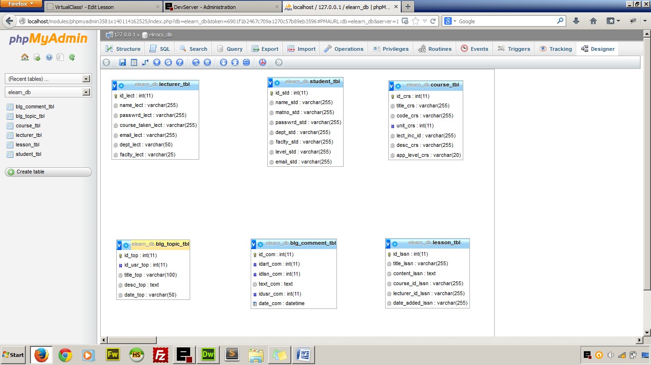

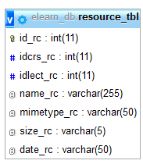

Figure 3.2 Entity Relationship Diagram of the Database “elearn_db”

# CHAPTER FOUR

# RESULT AND DISCUSSION

## 4.1 STUDENT SECTION

## 4.1.1 Login Page

The login page is characterised by menu that the user can click to access other pages and a login form that is required before a user is authorised. The student is required to enter his or Matric no that serves as the username and password. A login session is set before a user is granted access to the resources that are available. The entered Matric No and password is validated against the user’s details in the database and if there is a successful match, the student is redirected to the student’s homepage.

In case of a mismatch an adequate error message is displayed.

## 4.1.2 Homepage

After a successful log in the user is redirected to the student’s homepage where resources can now be accessed because of the active log in. The homepage is characterised by a brief history of what the student can do with the web application. The homepage also have a list of the recent lecture materials that was added to the database by the lecturers and below the page is the details of the logged in student such as full name, department, faculty, matriculation number and current level.

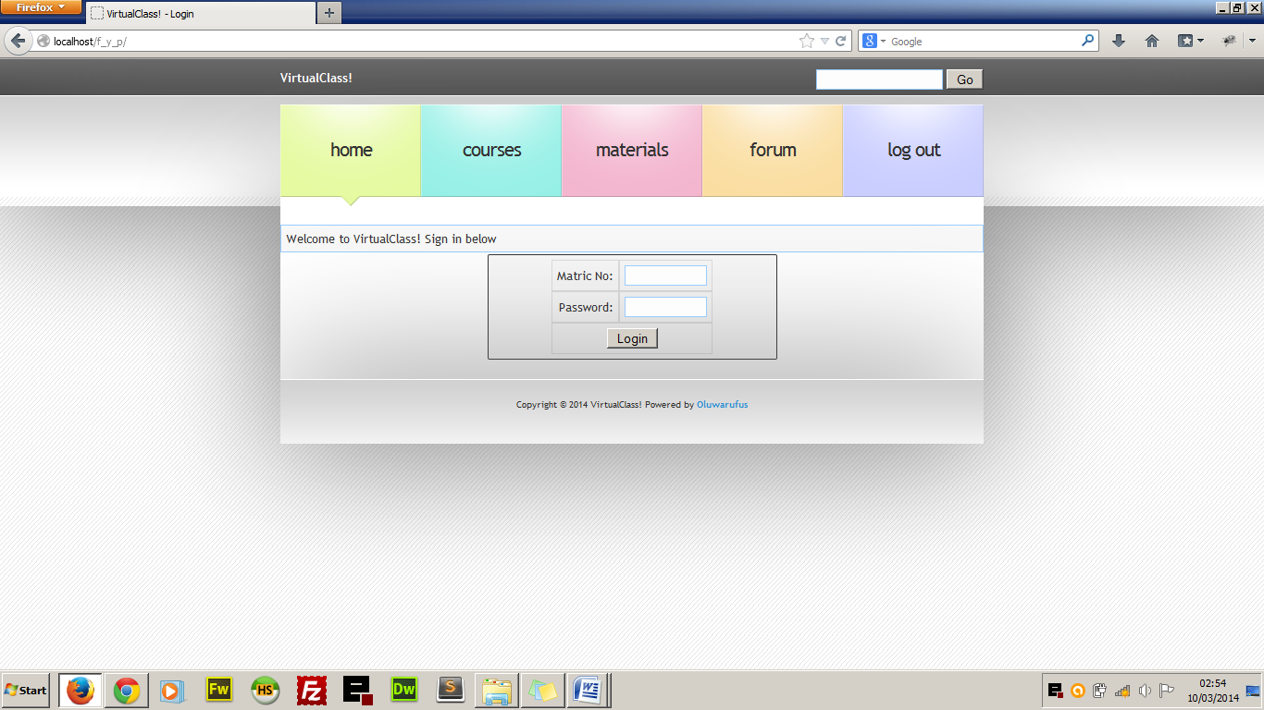

Figure 4.1 Login Page

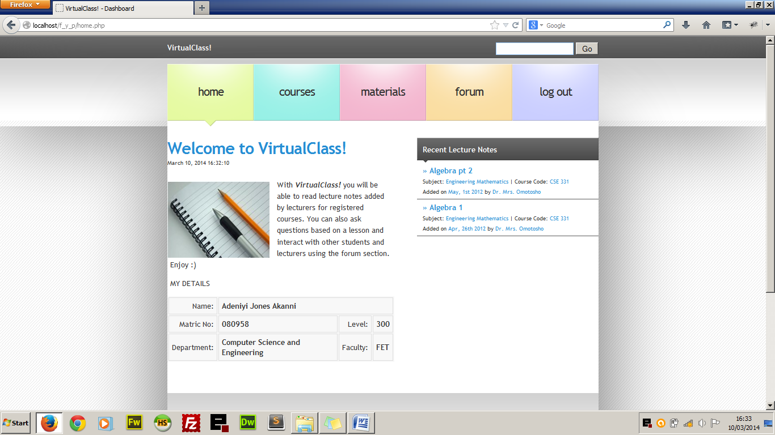

Figure 4.2 Student Home Page

## 4.1.3 Courses

When the student clicks on course from the main menu, he/she is redirected to the page that contains all the registered courses with a brief introduction to each course, course code and unit, the lecturer-in-charge and the number of lessons under each courses. Clicking the course title takes the student to the page that contains all the lessons under the course starting from the latest to the oldest. This helps students to read only the latest lesson notes first. This is as seen in fig. 4.3

## 4.1.4 Resources

This is the page that contains all the uploaded media documents added by the lecturers that can be viewed online or downloaded for offline reading as the case may be. The managers (the lecturers) have the privilege to upload a document, audio or video.

## 4.1.5 Forum

This is where discussion is carried out within the e-learning system. Students can ask question based on anything and get their colleagues to discuss any trending issue. The lecturers serve as the Forum Moderator that delete or block any irrelevant forum topic.

## 4.2 LECTURER SECTION

The lecturer section is where the links to manage the courses lies and it can only be accessed using username and password given to lecturers. The username in the case of the lecturer is the email address of the lecturer and a predefined password. The lecturers’ section contains the tools in three subsections which include:

1. Course Lesson Management
2. Course Material Management
3. Forum Management

## 4.2.1 Course Lesson Management

The lecturer is able to manage only the course which he is assigned to. Management in the sense that lecturers will be able to add lesson notes to their courses, edit the lesson notes as the case may be and delete the lesson note if necessary. They will also be able to see comments posted by students to each lessson and reply if it is a question or delete from the database if it is a profane comment.

## 4.2.2 Course Resources Management

Lecturers using the web application will be able to upload files which could be normal documents or audio visual files that could help the student further in their studies. Lecturers are granted the privilege of adding and deleting as the case maybe. The uploaded material is bounded with the course that the lecturer is taking.

## 4.2.3 Forum Management

We cannot deny the fact that there are always excesses when it comes to student giving reviews and comments and this is why lecturers are given the role of managing the discussion forum. They are given the privilege of deleting forum topics that are not educational and also delete comments that are irrelevant to ongoing discussion.

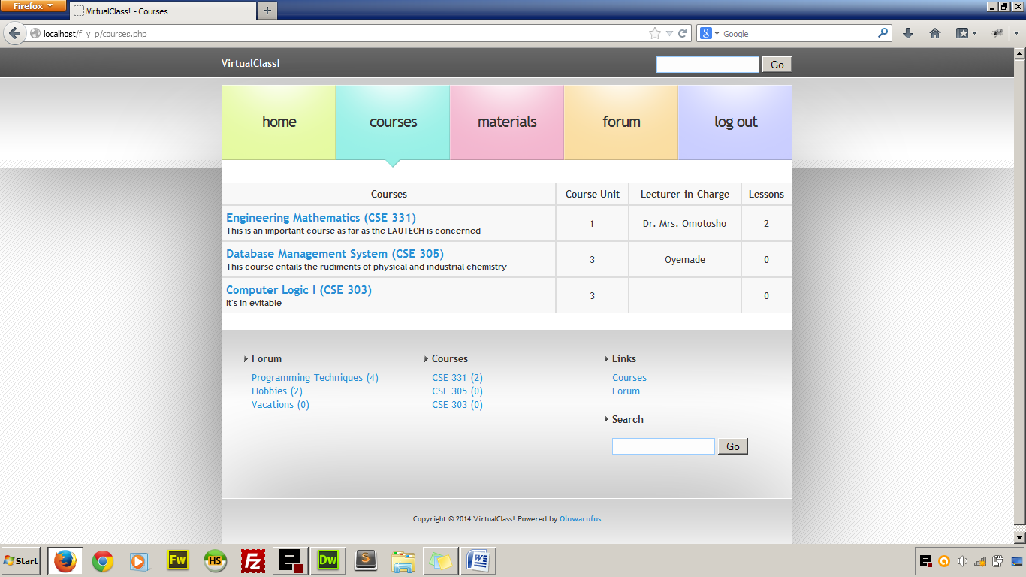

Figure 4.3 Course Page

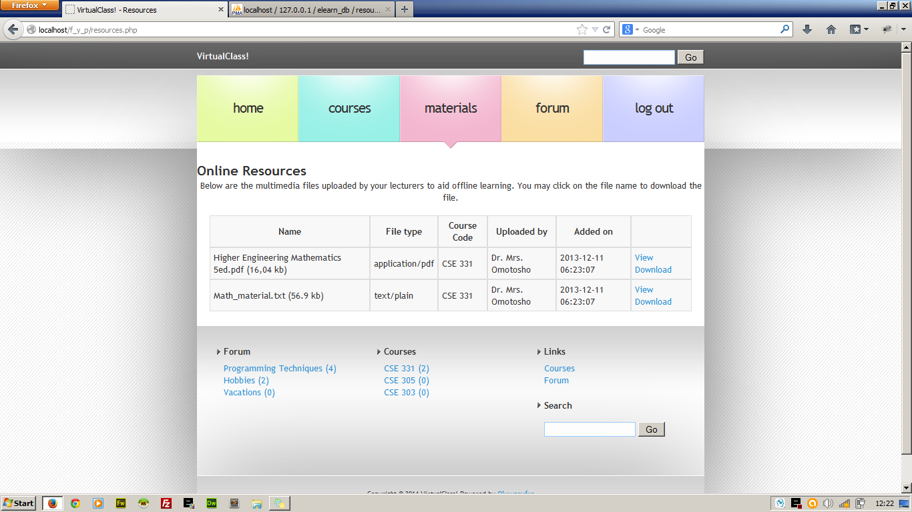

Figure 4.4 Students’ Resources Page

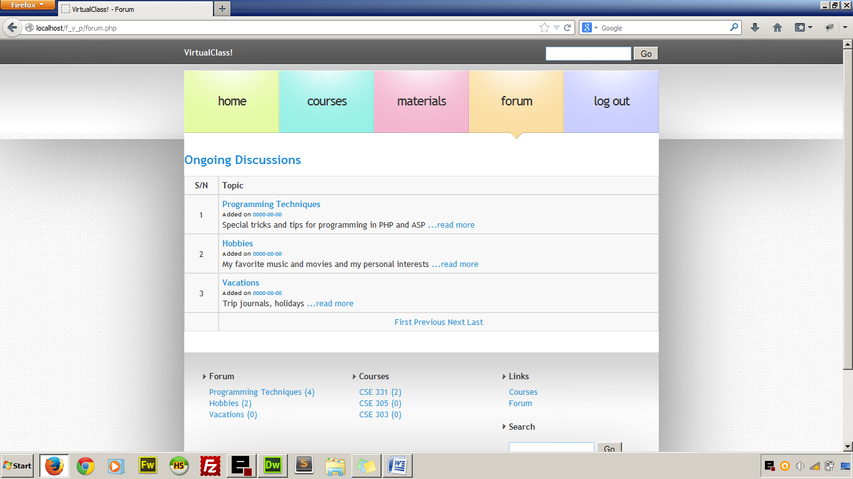  
Figure 4.5 Forum Page

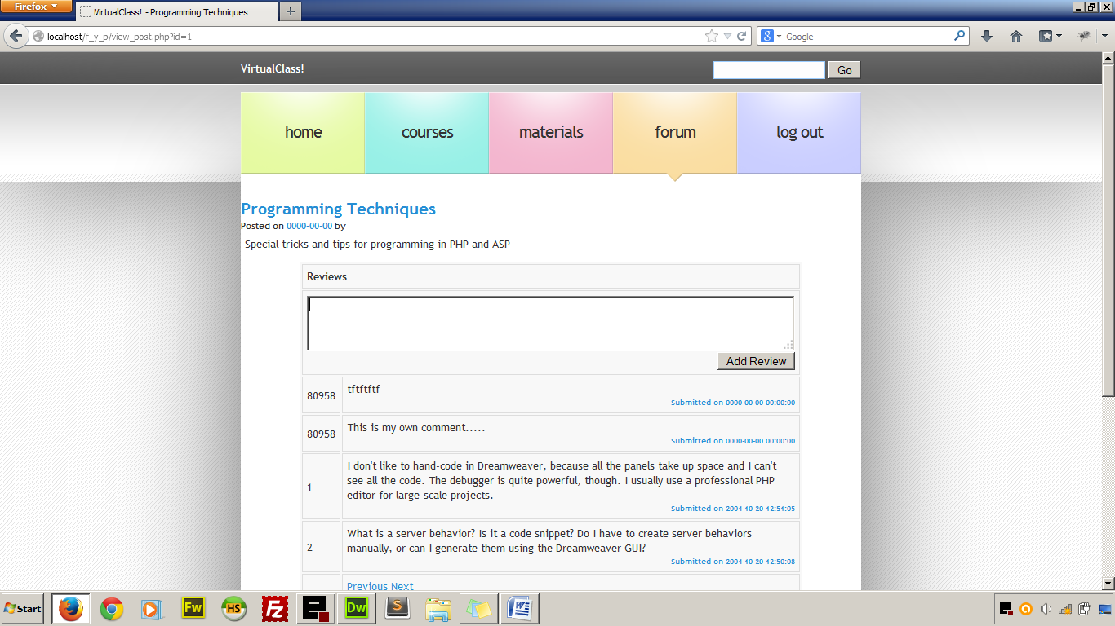

Figure 4.6 Forum Discussion Page Showing the Review Form

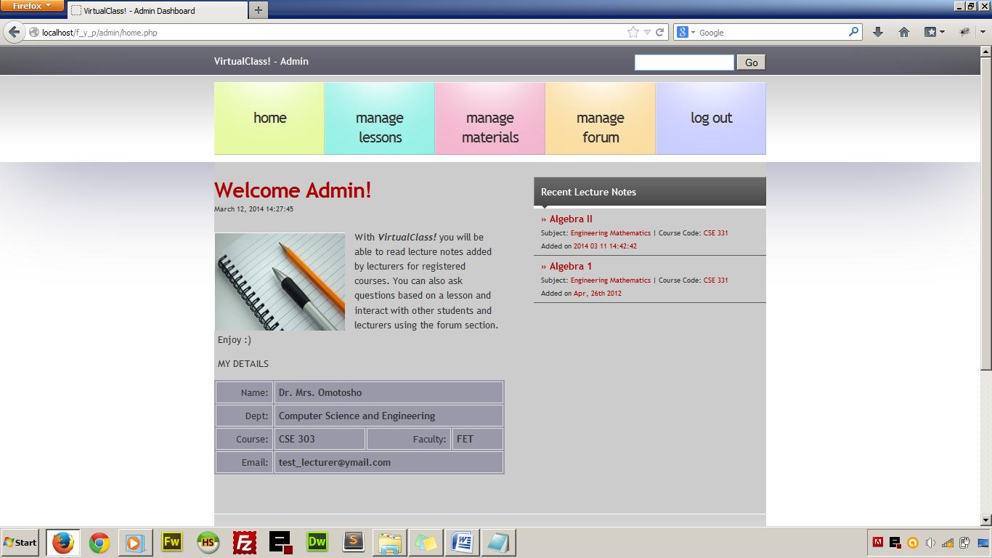

Figure 4.7 Lecturer’s Homepage

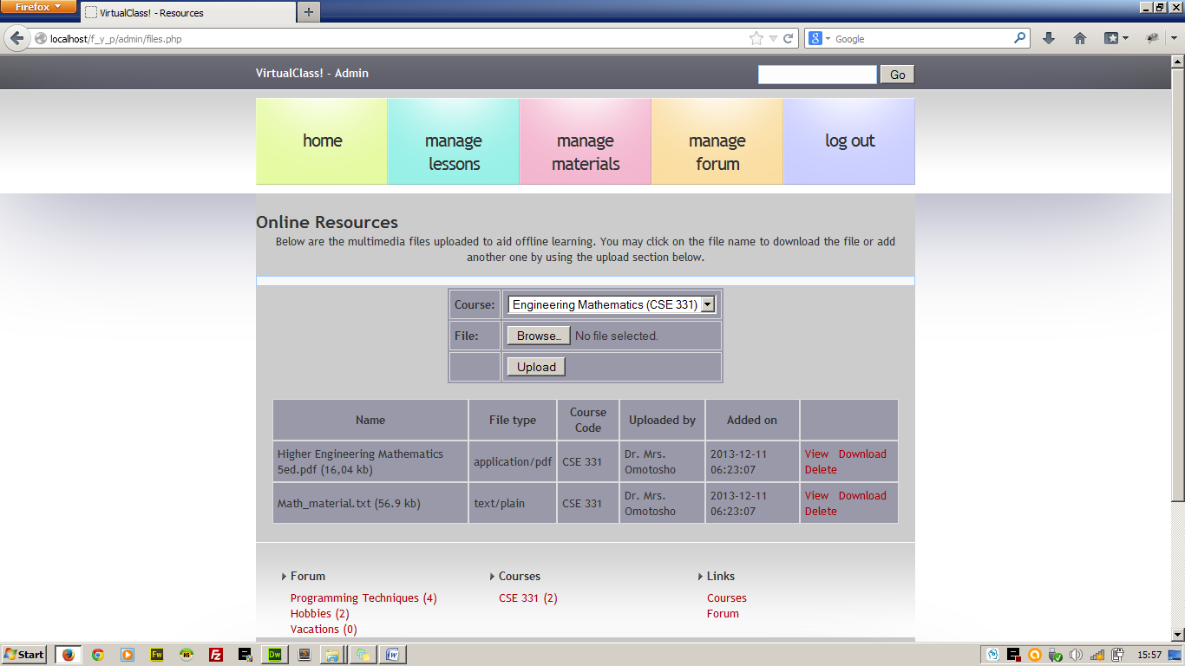

Figure 4.8 File Management Page

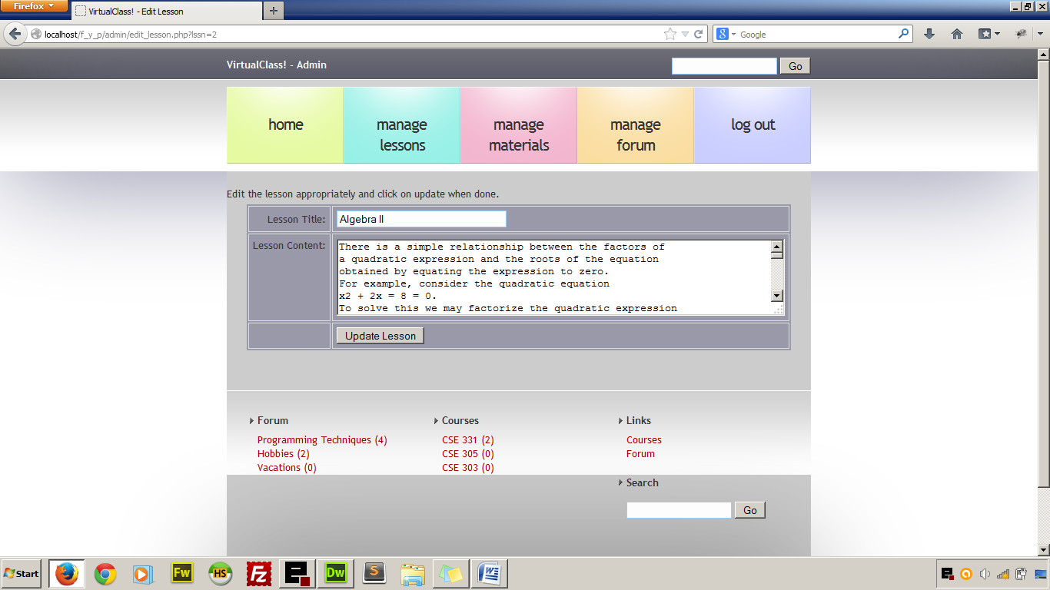

Figure 4.9 Lesson Update Page.

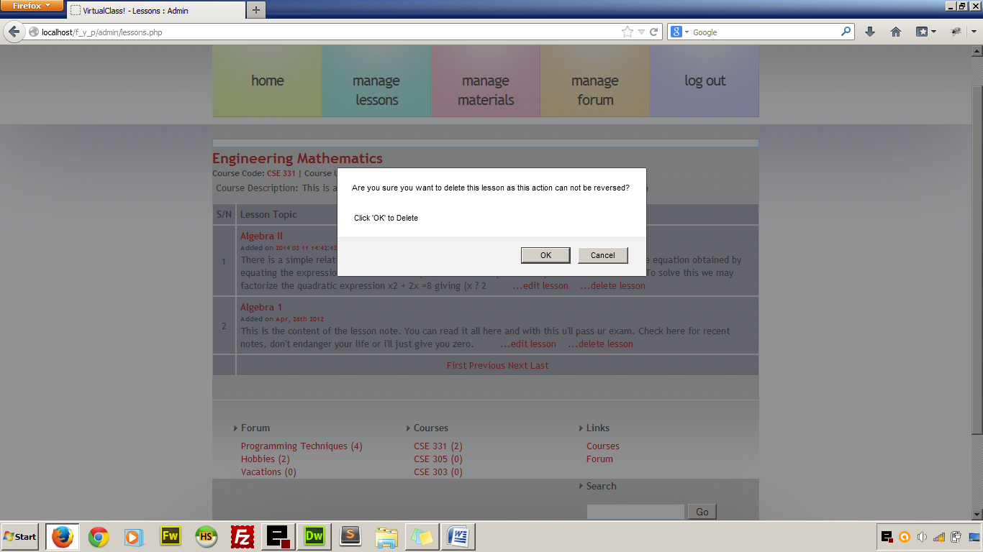

Figure 4.10 Lecturer Deleting a Lesson

# CHAPTER FIVE

# CONCLUSION AND RECOMMENDATION

## 5.1 CONCLUSION

Conventional teaching system is still favourable in the tertiary educational system in Nigeria but a handful of universities have embraced online lecture delivery system in order to synchronize lectures and courseware materials for their distant learning students and for their in-campus students. The adoption of online synchronisation of lecture materials will adequately supplement the conventional face-to-face teaching system; most lecturers will find it easy to run online version of their courses and at the same time deliver face-to-face lectures at their convenience. For instance, in a course where most of the required materials have been given beforehand online, the lecturer will only need a class or two to explain course contents which will ordinarily take them eight to ten classes to explain. On the other hand, students will acclimatize quickly on the online environment and with formal adoption of this lecturing system, they will learn quickly and more efficiently.

This project is practical example of custom-built E-learning system that supports the academic curriculum in use in Nigeria. It is built to support integration with other educational web application such as online grading systems which could be deployed with it as the need be.

## 5.2 RECOMMENDATIONS

For smooth and effective online lecture delivery, the stake holders in the educational sector such as the governments, school management boards, parents, etc. are hereby enjoined to provide the following:

1. Adequate infrastructural facilities in universities to support online lecture delivery.
2. Adoption of the online learning system as part of the learning structures in the federation
3. Encouragement to students by making available affordable computer devices as well as internet connectivity.
4. Establishment of favourable technological policies that will increase the rate of ICT adoption.

# REFERENCES

Arbaugh, J.B., and Duray, R. (2002). Technological and Structural Characteristics, Student Learning and Satisfaction With Web Based Courses. Management Learning, Vol.3, Pp 1-15.

Arison, D., and Cuthbertson, C., (2002), Management Approach to Database Application [In A Relational Environment], McGraw-Hill, Vol.34, No.3, Pp 34-38

Barkan, M., and Ozad, B Open Learning: The Way Ahead. Paper Presented In the First Open Learning Symposium, Esksehir, Turkey.

Barry, M., and Runyan, G., (1995). A Review of Distance Learning Studies in the U.S. Military. The American Journal of Distance Education, Vol. 9, No.3, Pp 37-47.

Beard L.A., and Harper C. (2002). Student Perceptions of Online Versus On Campus Instruction. Education, Vol. 122, No.4, Pp 658-663.

Berge, Z.L. (1997). Group Computer Conferencing: Summary of Characteristics and Implementations for Future Research. Distance Education Symposium 3: Course Design, Pp 42-57.

Breen L., Cohen L., and Change P., (2003). Teaching and Learning Online For the First Time; Student and Coordinator Perspectives. Paper Presented At The Partners In Learning; 12th Annual Teaching Learning Forum, Edith Cowan University, Perth.

Bri, D., Gracia, M., Coll, and Lloret, J. (2009). A Study of Virtual Learning Environment, WSEASTransactions on Advances in Engineering Education, Vol. 6, No. 1, Pp 1-15.

Brown, B., and Liedholm, C., (2002). Can Web-Courses Replace The Classroom In Principles of Microeconomics? American Economic Review, May 2002.

Buckley, K.M., (2003). Evaluation of Classroom-Based, Web –Enhanced, and Web –Based Distance Learning Nutrition Course For Undergraduate Nursing. Nursing Education, Vol.42, Pp 367-370.

Crey, J., (2001). Effective Student Outcomes: A Comparison of Online and Face-To-Face Delivery Modes; Distance Education Online Symposium.

Caywood, K., and Duckett, J. (2003). Online Vs. On-Campus Learning In Teacher Education.Teacher Education and Special Education ,Vol. 26, No.2, Pp 98-105.

Cheng H., Lehman, J., and Armstrong P., (1991). Comparison of Performance and Attitude in Traditional and Computer Conferencing Classes, the American Journal of Distance Education, Vol. 5, No. 3, Pp 51-64.

Clark T. (1993). Attitudes of Higher Education Faculty Toward Distance Education. Vol. 10, No.2, Pp 4-36.

Coombs-Richardson, R., (2007). Personalizing Distance Learning. Kappa Delta Pi, Winter, Pp 71–75

Derousa, E., and Fleming, M., (2003). A Comparison of In-Class Quizzes vs. Online Quizzes on Students Exam Performance. Journal of Computing In Higher Education. Vol. 14, No. 2, Pp 121-134

Drewitz, I., (2009), Evaluation of E-Learning Platforms. Msystech Journal, Vol. 1 No. 1 Pp 1-16

Gresh S. K., and Mrowzowski, S. (2000). Faculty/ Students Interaction at a Distance: Seeking Balance. The John Hopkins School of Public Health, Vol. 1 Pp 1-9.

Hiltz S. R., Benbauch-Fich R., and Coppola, N., (2000). Measuring The Importance of Collabortive Learning For The Effectiveness of Aln: A Multi-Measure, Multi-Method Approach. Journal of Asynchronous Learning Networks, Vol. 4, No. 2.

Hiltz, S., (1993). Correlates of Learning In A Virtual Classroom, International Journal of Man-Machine Studies, Vol. 39, Pp 71-98.

Institute for Higher Education Policy. (1999). What's the Difference? A Review of Contemporary Research On The Effectiveness of Distance Learning In Higher Education.

Johnson, S. D., Aragon, S. R., Shaik, N., and Palma-Rivas. N., (2000).Comparative Analysis of Learner Satisfaction and Learning Outcomes in Online and Face-to-Face Learning Environments. Journal of Learning Research, Vol. 11, No. 1, Pp 29-50.

Jonassen D. H., (1999). Designing Constructivist Learning Environments: A New Paradigm of Instructional Theory, Vol. 2, No. 1, Pp 215-239.

Jones V., Jo J. H. and Cranitch G. (2000) A Study of Students Response To Wbi Within A Traditional Learning Environment, Conference Proceedings Ausweb2k, Cairns, Australia.

Jones V., Jo J. H. and Cranitch G. (2000) The Evolution of A Multimedia Delivery System and Its Effects On Students Perception and Performance, Conference Precedings Ascilite 2000, Coffs Harbor, Australia.

Kearsley G. (2000). Online Education: Learning and Teaching in Cyberspace, Wadsworth, Vol. 2, Pp 1-5

Khadare, S. S., (2004), Database Management and Oracle Program, Rajendra Rarundrar Printers (Ptr) Ltd., Vol. 1, No. 1, Pp 1 -35.

Lawther, P. M., and Walker, D. T., (2001). An Evaluation of Distributed Learning System. Education and Training, Vol. 43, No. 2, Pp 105-116.

Leasure, R., Davis, L. A. and Thievon, S., (2000). Comparison of Student Outcomes and Preferences In A Traditional Vs. Worldwide-Web-Based Baccalaurette Nursing Research Course. Journal of Nursing Education, Vol. 39, Pp 149-154.

Lewis B. A. and Macentee, V. M., (2005). Learning Management System Comparison, Informing Science and It Education Joint Conference, Vol. 1 No. 2, Pp 1-15

Maki R. H., Maki W. S., Patterson M., and Whittaker P. D. (2000). Evaluation of A Web-Based Introductory Psychology Course. Learning and Satisfaction In Online Vs. Lecture Courses, Behavior Research Methods. Instruments and Computers Vol. 32, Pp 230-239

Maki R. and Maki W. (2003). Prediction of Learning and Satisfaction in Web-Based and Lecture Courses. Journal of Educational Computing Research, Vol. 28, No. 3. Pp 197-219.

Maki W. S. and Maki R. H. (2002). Multimedia Comprehension Skill Predict Differential Outcomes of Web-Based and Lecture Courses. Journal of Experimental Psychology: Applied, Vol. 8, Pp 85-98.

O’Leary, A. (1999). Get Wired, Go Digital, Build A Web-Based Learning Community. The Web Net Journal, Vol. 1, No. 1.

Parise, P. (2000). Herding Cats: How Are Online Classes Changing The Educational Paradigm? Library Computing, Vol. 19. Pp 93-97.

Petrides, L. A., (2002). Web-Based Technologies For Distributed (Or Distance) Learning: Creating Learning Centered Educational Experiences In The Higher Education Classroom. International Journal of Institutional Media, Vol. 29, No. 1, Pp 69-77.

Phipps, M., Merisotis, O., and O’Brien. N. M., (1999). “What’s The Difference? A Review of Contemporary Research On The Effectiveness of Distance Learning In Higher Education, The Institution For Higher Education, Washington, Dc, Vol. 1, Pp 12-15.

Reeves T., and Reeves P., (1997). Effective Dimensions of Interactive Learning On The Worldwide Web, In Web Based Instruction, Educational Technology Publications, Englewood Cliffs, NJ.

Rengarajan, R., (2001). LCMS and LMS: Taking Advantage of the Tight Integration. Internal Journal of E-Learning, Vol. 16. Pp 57-65.

Roblyer, M. D., (1999). Is Choice Important In Distance Learning? A Study of Student Motives For Taking Internet-Based Courses At The Higher School and Community College Levels. Journal of Research on Computing In Education, Vol. 32, Pp 157-171.

Russell. T., (1999). The No Significant Difference Phenomenon, office of Instructional Telecommunications, North Carolina State University.

Sampson,N., (2003). Meeting the Needs of Distance Learners. Language, Learning, and Technology, Vol.7, Pp 103-126.

Sankaran, S., Sankaran, P., and Bu, M., (2000) .Effect of Student Attitude To Course On Learning Performance: An Empirical Study In Web Vs. Lecture Instruction. Journal of Instructional Technology, Vol.27, Pp 66-73.

Scheines R., Leichardt, G., Smith J., and Cho K. (2001). Replacing Lecture with Web-Based Course Materials. A. W. Mellon Foundation’s Cost-Effective Uses of Technology in Teaching Program, Vol. 1, Pp 1-37.

Sener, J., (2001). Bringing Aln into the Mainstream: Nvcc Case Studies, In Online Education, Proceedings of the 2000 Summer Workshop on Asynchronous Learning Networks, Vol. 2.

Sharma R., Haom, Dayal U., Bash, and Patel C. (2009). Mobile Visual Analytics for Data Center Power and Cooling Management. Mobicase2009: Annual International Conference On Mobile Computing Applications and Services, Vol. 6 No. 3, Pp 172-3.

Sinclair, J., (1999). Everybody’s Gone Surfing, The Age, Melbourne, Published 19 June 1999.

Smith, G. G., and Ferguson, D. (2002). Teaching Over The Web Vs. In The Classroom: Differences in the Instructional Media, Vol. 29, No. 1, Pp 61-67.

Song L., Singleton E., Hill J., Koh M (2004). Improving Online Learning: Student Perceptions of Useful and Challenging Characteristics, The Internet Higher Education, Vol. 7, No.1 Pp 59-70.

Tang, M., and Byrne, R. (2007). Regular Vs. Online Vs. Blended: A Quantitative Description of The Advantages of The Electronic Modes and A Quantitative Evaluation. International Journal of E- Learning, Vol. 6 Pp 257-266.

Wang, Y., and Newlin, M., (2000). Characteristics of Students Who Enrol and Succeed In Psychology Web-Based Classes. Journal of Education Psychology, Vol. 92, Pp 137-143.

Ward, M., and Newlands D. (1998). Use of Web in Undergraduate Teaching. Computers and Education, Vol. 31, Pp 171-184.

Wegner S.B., Holloway K. C., and Garton E.M., (1999).The Effects of Internet-Based Instruction On Student Learning, Journal of Asynchronous Learning Networks, Vol. 3, No. 2, Pp 98-106.

Willett, H. G., (2002). Not One of the Other but Both: Hybrid Course Delivery Using Webct. The Electronic Library, Vol. 20, No. 5, Pp 413-419.

Yazon, J. M., Mayer- Smith, J. A., and Redfield, R. J. (2002).Does The Medium Change the Message? The Impact of a Web-Based Genetics Course on University Students Perspectives on Learning and Teaching. Computers and Education, Vol. 32, Pp 267-285.